|  |  |  |  |  |  |  |  |  |  |  |  |
| --- | --- | --- | --- | --- | --- | --- | --- | --- | --- | --- | --- |
|  | | **Hope Foundation’s,**  **Finolex Academy of Management and Technology, Ratnagiri** | | | | | | | | | |
| **Department of Information Technology** | | | | | | | | | |
| Subject name: OLAP LAB | | | | | | | | Subject Code: ITL503 | | | |
| Class | | TE IT | | Semester – V (CBCGS) | | | | Academic year: 2018-19 | | | |
| Name of Student | | **Kazi Jawwad A Rahim** | | | | | **QUIZ Score : 03** | | | | |
| Roll No | | **32** | | | Experiment No. | | | | | 07 | |
| Title**: To implement Temporal Database** | | | | | | | | | | | |
|  | | | | | | | | | | | |
| 1. **Course objectives applicable:**   **LOB1**- To impart an overview of temporal databases. | | | | | | | | | | | |
| 1. **Course outcomes applicable:**   **LO1**- To understand basics of temporal database | | | | | | | | | | | |
| 1. **Learning Objectives:**  * To be able to design temporal database | | | | | | | | | | | |
| 1. **Practical applications of the assignment/experiment:**  * Academic, Accounting, Data warehouse. | | | | | | | | | | | |
| **5. Prerequisites**: Students should be familiar with basic concepts in databases (including relational databases, SQL) | | | | | | | | | | | |
| **6. Hardware Requirements**:   1. PC with 4GB RAM, 500GB HDD,   **7. Software Requirements:**  1. SQL Server 2012 | | | | | | | | | | | |
|  | | | | | | | | | | | |
| **8. Quiz Questions (if any): (Online Exam will be taken separately batch wise, attach the certificate/ Marks obtained)**  https://goo.gl/2uAC1F | | | | | | | | | | | |
|  | | | | | | | | | | | |
| **9. Experiment/Assignment Evaluation:** | | | | | | | | | | | |
| **Sr. No.** | **Parameters** | | | | | | | | **Marks obtained** | | **Out of** |
| **1** | Technical Understanding (Assessment may be done based on Q & A **or** any other relevant method.) Teacher should mention the other method used - | | | | | | | |  | | 6 |
| **2** | Neatness/presentation | | | | | | | |  | | 2 |
| **3** | Punctuality | | | | | | | |  | | 2 |
| **Date of performance (DOP)** | | |  | | | **Total marks obtained** | | |  | | **10** |
| **Date of checking (DOC)** | | |  | | | **Signature of teacher** | | | | | |

**Result :-**

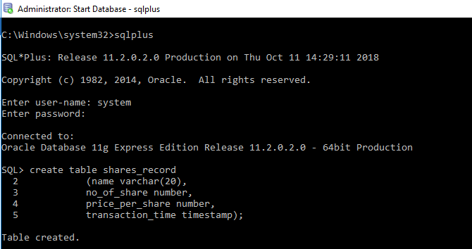**Creating table Shares_record :**

**Record Insertion :**

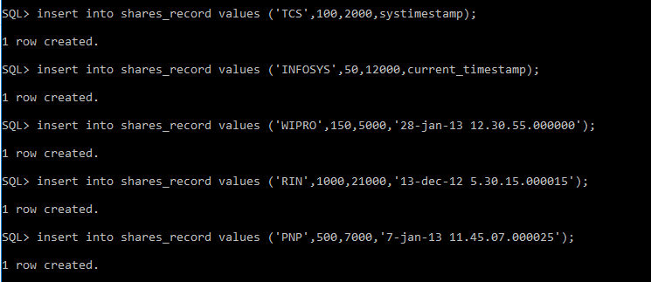

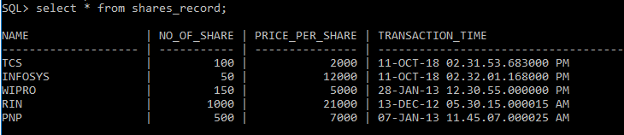**Checking Records :**

**FIRING QUERIES :-**

**1. Select the details of the Share when transaction time is less than current timestamp.**

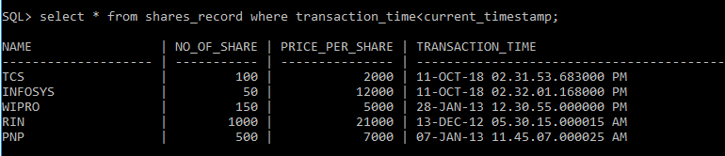

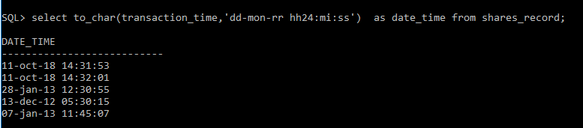**2.** **Display the transaction time in 24 hour format.**

1. 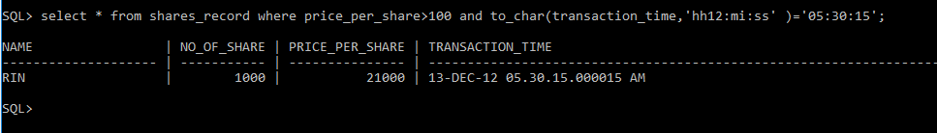**Select the details when share price is greater than 100 at 11:45 AM.**

**References**:

1. C. Bettini, S. Jajodia, X. S. Wang. Time Granularities in Databases. Data Mining, and Temporal Reasoning, chap. 2, Springer-Verlag, July 2000.
2. C. S. Jensen, M. D. Soo, and R. T. Snodgrass. Unification of Temporal Data Models. ICDE 2003, pp. 262-271, 1993.
3. M. H. Böhlen, C. S. Jensen. Temporal Data Model and Query Language Concepts. Encyclopedia of Information Systems, Volume 4, Elsevier Science, 2003.
4. http://www.timeconsult.com/TemporalData/TemporalDB.html#Temporal%20Databases